1.
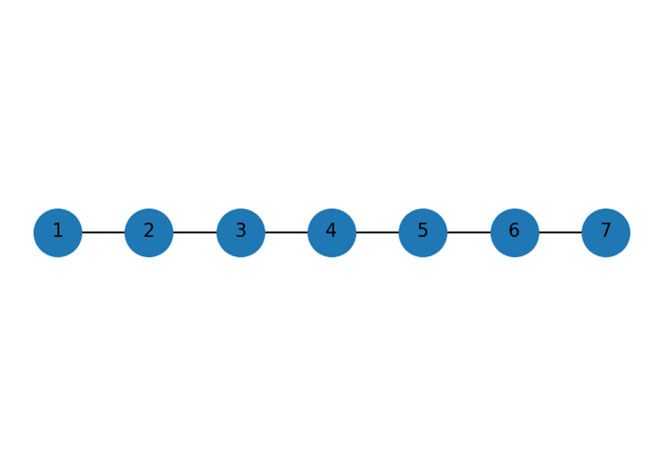
For this graph, we need to find k and n. The nodes to the left of “v” us represented by k-1. The number of the nodes to the right are represented by n-k.
For the formula, Cb(k) = (k-1)(n-k), we can apply all of the nodes as values of k.
Node 1: (1-1)(7-1) = 0x6 = 0
Node 2: (2-1)(7-2) = 1x5 = 5
Node 3: (3-1)(7-3) = 2x4 = 8
Node 4: (4-1)(7-4) = 3x3 = 9
Node 5: (5-1)(7-5) = 4x2 = 8
Node 6: (6-1)(7-6) = 5x1 = 5
Node 7: (7-1)(7-7) = 6x0 = 0
Raw Centralities are as follows:
[0,5,8,9,8,5,0]
Now we must normalize the number of pairs not involving v by finding the total number of paths that include the node divided by the total number of paths using our raw centrality values.
Node 1 = 0/15 = 0
Node 2 = 5/15 = 0.333
Node 3 = 8/15 = 0.533
Node 4 = 9/15 = 0.600
Node 5 = 8/15 = 0.533
Node 6 = 5/15 = 0.333
Node 7 = 0/15 = 0
Final normalized values are as follows:
[0,0.333,0.533, 0.600, 0.533, 0.333, 0]
2.
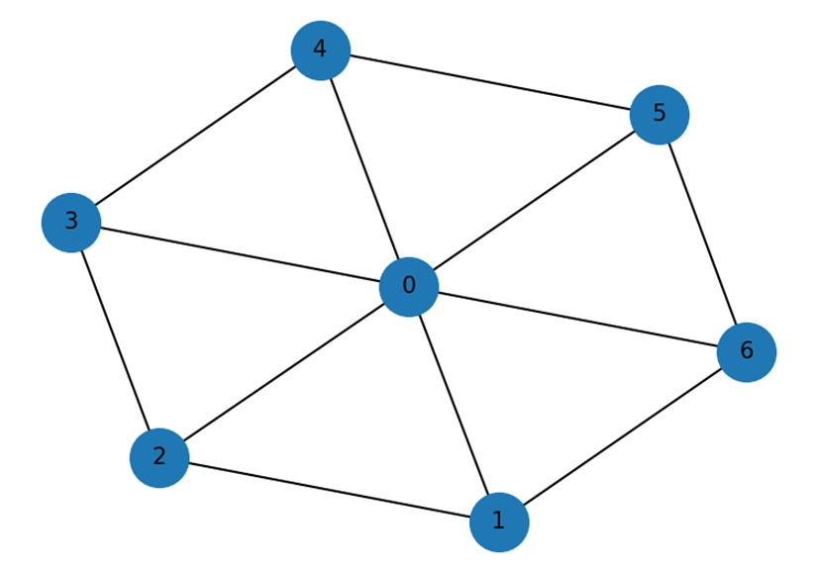
N = 7 nodes total. Node 0 is the center hub, Nodes 1-6 are the rim in a 6 cycle. We only care about unordered pairs where v isn’t an endpoint. We have 7 nodes so we can find the normalization factor for the path using the (n-1)(n-2)/2. We must have 3 separations between two rim nodes.
We have 15 total paths available.
Separation 1 (adjacent on the cycle) = 6 unordered pairs
Separation 2 (one node between them on the cycle) = 6 unordered pairs
Separation 3 (Opposite on the 6-cycle) = 3 unordered pairs
Since the hub is not unique on the shortest path, the contribution is 0 per pair.
For separation 2, we have 6 = 2, or 6/2 or 3.
For separation 3, we have the hub giving the unique shortest path with 2 length while the shortest path along the cycle is 3. There is 1 contribution for each of the 3 pairs, so the contribution is 3.
Cb(0) = 0+3+3 = 6
C’b(0) = 6/15 = 0.400
Each node 1-6 have a Contribution of 0.5 and C’b = 0.5/15 = 0.03333.
The summation of Cb(v) = Cb(0) + 6x0.5 = 6 + 3 = 9
So the numbers are consistent.
Pair {s,t}\{s,t\}{s,t} | Shortest paths (σst\sigma_{st}σst​) | Paths through 1 (σst(1)\sigma_{st}(1)σst​(1)) | Contribution (σst(1)/σst\sigma_{st}(1)/\sigma_{st}σst​(1)/σst​)

{2,3} | 1 (2–3) | 0 | 0

{2,4} | 2 (2–3–4, 2–0–4) | 0 | 0

{2,5} | 1 (2–0–5) | 0 | 0

{2,6} | 2 (2–1–6, 2–0–6) | 1 (2–1–6) | 0.5

{3,4} | 1 (3–4) | 0 | 0

{3,5} | 2 (3–4–5, 3–0–5) | 0 | 0

{3,6} | 1 (3–0–6) | 0 | 0

{4,5} | 1 (4–5) | 0 | 0

{4,6} | 2 (4–5–6, 4–0–6) | 0 | 0

{5,6} | 1 (5–6) | 0 | 0

